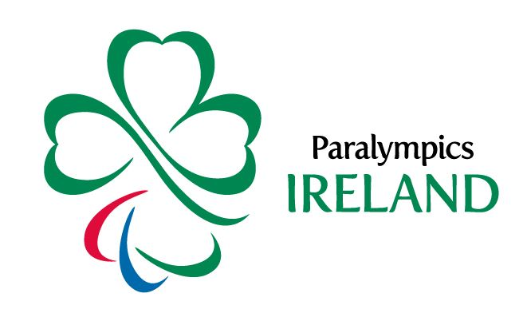
Paralympics Ireland Para Athletics Talent Search

Please complete the following form to support your video application
Name:
Address:
Date of Birth:
Contact email:
Impairment: please select at least one impairment from the list of eligible Paralympic impairments
☐Hypertonia
☐Ataxia
☐Athetosis
☐Limb Deficiency
☐Impaired Muscle Power
☐Leg Length Difference
☐Impaired Passive Range of Movement
☐Visual Impairment
☐Unknown
☐Other (please state):
Height (cm):
Weight (kg):
Are you currently involved in Athletics? If YES, tell us your event/s and best performance/s here:
Are you currently involved in another sport? If YES, tell us your sport/s and best performance/s here:
Years of sporting involvement:
Highest level of sporting achievement:
Sporting ambitions:
Highest education to date:
Other interests:
Athletic Activities - when undertaking the required activities for your own video. Tell us how far you threw for the chest pass and overhead throw, and jumped in the standing long jump (e.g. overhead throw = 10 metres).

Please email completed application form to para-athletics@paralympics.ie

